HONORS CHEMISTRY • UNIT 6
Stoichiometry
Use a balanced equation like a recipe: predict how much you need, how much you make, what runs out first, and how well the lab went.

HOW TO USE THIS PACKET
Write in pencil. Every calculation needs a setup with units, an answer with the right number of sig figs, and the substance named. LAB CORNER boxes are things you would see at a lab bench. Extra practice and a review are at the back.

What we will learn
6.1 | Mole ratios
6.2 | Mass-to-mass stoichiometry
6.3 | Liters and particles (gas volume at STP)
6.4 | Limiting and excess reactants (BCA tables)
6.5 | Theoretical, actual and percent yield

By the end of this unit I can…
• Write mole ratios from a balanced equation and use them to convert between moles of two substances.
• Solve mass-to-mass problems using a mole map and show every unit.
• Convert between liters of gas at STP, moles, grams and particles.
• Identify the limiting reactant and calculate product made and excess left over using a BCA table.
• Calculate theoretical yield and percent yield, and explain why actual yield is smaller.
6.1 | Mole Ratios The coefficients of a balanced equation are a recipe

BIG IDEA
A balanced equation tells you how many particles react, and since a mole is a counting number, the coefficients also give moles. The mole ratio is a conversion factor built from two coefficients. It is the only bridge between one substance and another.

Key vocabulary — write each definition in your own words
Term | Definition (your words) | Example / sketch
Stoichiometry | What is it used for?
Mole ratio | Where does it come from?

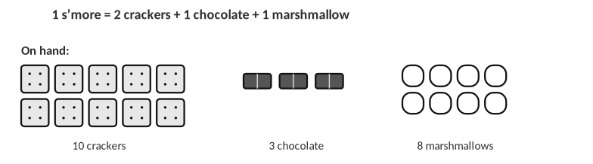
Analogy: the recipe 2 crackers : 1 chocolate : 1 marshmallow plays the role of the coefficients.
1. Use the s’more recipe. How many s’mores can you make from 6 chocolates if you have plenty of everything else? How many crackers does that use? Write the two ratios you used.

2. What do you need before you can write a mole ratio? Why must the equation be balanced first?

Write the mole ratios
Equation | Ratios (write each as a fraction)
N₂ + 3H₂ → 2NH₃ | N₂/H₂ = ______ N₂/NH₃ = ______ H₂/NH₃ = ______
8H₂ + S₈ → 8H₂S | H₂/H₂S = ______ H₂/S₈ = ______ H₂S/S₈ = ______

3. Hydrogen gas reacts with oxygen gas to make water. (a) Write the balanced equation. (b) Write the ratios H₂/O₂, H₂/H₂O and O₂/H₂O. (c) How many moles of water form from 10 moles of hydrogen?
a. Balanced equation
Work:

Answer (units & sig figs): __________________________________
b. Mole ratios
Work:

Answer (units & sig figs): __________________________________
c. Moles of water
Work:

Answer (units & sig figs): __________________________________
WORKED EXAMPLE — MOLE RATIO
How many moles of NH₃ form from 4.0 mol N₂? N₂ + 3H₂ → 2NH₃

Work it out here:

Answer: __________________________________
4. Use N₂ + 3H₂ → 2NH₃.
a. If 10 moles of NH₃ are produced, how many moles of N₂ were needed?
Work:

Answer (units & sig figs): __________________________________
b. If 3.00 moles of H₂ are used, how many moles of NH₃ are made?
Work:

Answer (units & sig figs): __________________________________
c. If 0.600 moles of NH₃ are produced, how many moles of H₂ are required?
Work:

Answer (units & sig figs): __________________________________
5. The reaction between hydrazine (N₂H₂) and hydrogen peroxide (H₂O₂) fuels rockets. The products are nitrogen gas and water. (a) Write the balanced equation. (b) How many moles of N₂ form from 37 moles of hydrazine? (c) If 23 moles of water form, how many moles of H₂O₂ were used?
a. Balanced equation
Work:

Answer (units & sig figs): __________________________________
b. Moles of N₂
Work:

Answer (units & sig figs): __________________________________
c. Moles of H₂O₂
Work:

Answer (units & sig figs): __________________________________
6.2 | Mass-to-Mass Stoichiometry Grams → moles → moles → grams

BIG IDEA
You cannot compare grams of different substances directly, because a gram of one is not the same number of particles as a gram of another. Convert to moles, use the mole ratio, then convert back to grams.

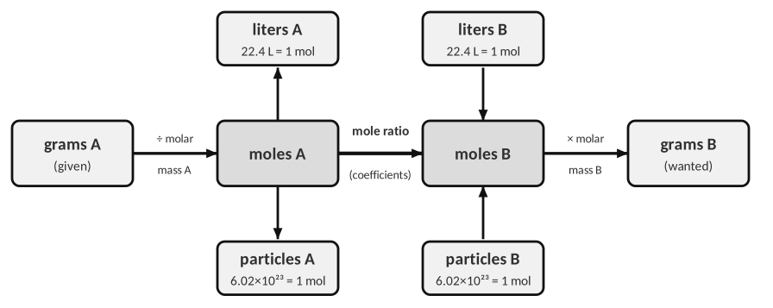
The mole map (use the top and bottom boxes in 6.3). Molar masses come from the periodic table.
1. In your own words, why is the mole ratio step the only step that uses the balanced equation? What do the other two steps use?

SETUP RULES
1. Balance the equation. 2. Write the given quantity with its unit and substance. 3. Chain factors so that each unit cancels. 4. Round the final answer to the sig figs of the given data.

WORKED EXAMPLE — GRAMS TO GRAMS
How many grams of FeS form from 5.9 g of Fe? (8Fe + S₈ → 8FeS)

Work it out here:

Answer: __________________________________
2. Use the equation Fe + S₈ → FeS. (a) Balance it.
a. Balance the equation
Work:

Answer (units & sig figs): __________________________________
b. How many moles of FeS are produced when 2.4 g of S₈ react?
Work:

Answer (units & sig figs): __________________________________
c. How many grams of iron are used if 11.9 g of sulfur (S₈) are used?
Work:

Answer (units & sig figs): __________________________________
3. Use the equation Fe₂O₃ + C → Fe + CO₂ (the reaction in a blast furnace).
a. Balance the equation
Work:

Answer (units & sig figs): __________________________________
b. How many grams of iron form if 39.64 g of carbon are used?
Work:

Answer (units & sig figs): __________________________________
c. If 63.12 g of iron(III) oxide are used, how many grams of carbon dioxide form?
Work:

Answer (units & sig figs): __________________________________
4. A student solved “grams of Fe₂O₃ → grams of CO₂” by multiplying by 159.7 g/mol and then by 44.01 g/mol, skipping the mole ratio. Describe what is wrong and what the student’s answer would represent.

5. To convert grams of A to grams of B you need…
A) molar masses only B) molar masses and the mole ratio C) the mole ratio only D) 22.4 L/mol
6.3 | Liters and Particles Gas volume at STP and counting atoms

BIG IDEA
At STP (0 °C and 1 atm), 1 mole of any gas occupies 22.4 L. This lets us convert between liters of a gas and moles, and so to any other substance. One mole is also 6.02 × 10²³ particles.

Key vocabulary — write each definition in your own words
Term | Definition (your words) | Example / sketch
STP | Two conditions and a number
Molar volume | Units?

THINK OF IT LIKE… A DOZEN IS JUST A NUMBER
A dozen is 12 things, whether they are eggs or elephants. A mole is 6.02 × 10²³ things, and at STP that many gas molecules take up 22.4 L whether they are H₂ or Cl₂. Gases are mostly empty space, so the size of the molecule hardly matters.

1. Explain why 1 mole of H₂ and 1 mole of Cl₂ occupy the same volume at STP even though a Cl₂ molecule is much heavier.

2. Hydrogen gas and oxygen gas combine to form water. Assume STP.
a. How many liters of H₂ are needed to make 3 moles of water?
Work:

Answer (units & sig figs): __________________________________
b. How many grams of water form from 30.2 L of hydrogen?
Work:

Answer (units & sig figs): __________________________________
c. How many grams of water form from 30.2 L of oxygen?
Work:

Answer (units & sig figs): __________________________________
d. When 120.3 g of water form, how many liters of hydrogen were used?
Work:

Answer (units & sig figs): __________________________________
LAB CORNER • Sodium azide in a car air bag

A crash sensor sets off the reaction NaN₃(s) → Na(l) + N₂(g). The nitrogen gas inflates the bag in about 0.03 seconds.
[ IMAGE GOES HERE ]
Photo or diagram of an air bag inflator (add your own)

3. Balance the equation, then solve (STP).
a. Balance the equation
Work:

Answer (units & sig figs): __________________________________
b. How many liters of N₂ form from 15.62 g of NaN₃?
Work:

Answer (units & sig figs): __________________________________
c. How many grams of NaN₃ are needed to produce 200.0 L of N₂?
Work:

Answer (units & sig figs): __________________________________
d. If 31.4 g of sodium are produced, how many liters of N₂ are produced?
Work:

Answer (units & sig figs): __________________________________
4. How many molecules of water form from 5.0 g of hydrogen gas? (2H₂ + O₂ → 2H₂O; 1 mol = 6.02 × 10²³ molecules)
Work:

Answer (units & sig figs): __________________________________
LAB CORNER • Hydrogen gas collected over water

A 0.150 g strip of magnesium reacts completely with excess hydrochloric acid. The hydrogen is collected in an inverted graduated cylinder.
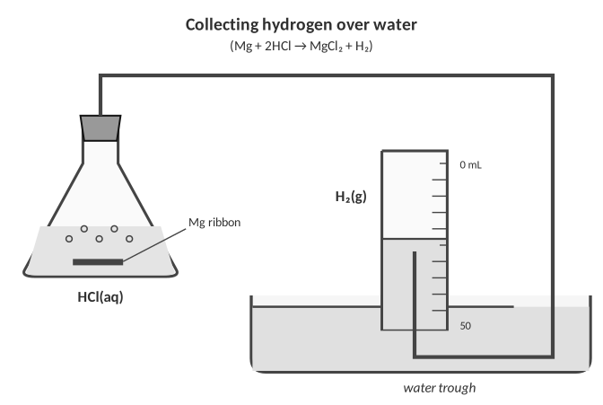
5. (a) Write the balanced equation. (b) Calculate the theoretical volume of H₂ at STP in mL. (c) The measured volume was 128 mL. Name one reason it differs.
a. Equation
Work:

Answer (units & sig figs): __________________________________
b. Theoretical volume
Work:

Answer (units & sig figs): __________________________________
c. Reason
Work:

Answer (units & sig figs): __________________________________
6.4 | Limiting and Excess Reactants Which ingredient runs out first?

BIG IDEA
Reactants are almost never mixed in perfect recipe amounts. The limiting reactant is the one that runs out first and so decides how much product forms. The excess reactant is what is left over when the reaction stops.

Key vocabulary — write each definition in your own words
Term | Definition (your words) | Example / sketch
Limiting reactant | What does it limit?
Excess reactant | What happens to it?

Recipe: 2 crackers + 1 chocolate + 1 marshmallow → 1 s’more.
1. Using the s’more recipe and the items shown: (a) How many s’mores can you make? (b) What is the limiting “reactant”? (c) What is left over, and how many of each?
Work:

BCA TABLE STEPS (MOLES!)
1. Balance the equation. Convert every given amount to moles.
2. Divide each by its coefficient; the smallest value is the limiting reactant.
3. Before row = starting moles. Change row = the limiting reactant goes to 0; use the mole ratio for the rest (reactants −, products +).
4. After row = Before + Change. Convert the After amounts to the unit the question asks for.

Particle picture: N₂ + 3H₂ → 2NH₃
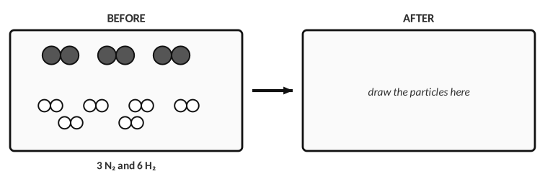
2. Which reactant is limiting? Draw the particles after the reaction in the AFTER box, then say how many N₂ molecules are left.

WORKED EXAMPLE — BCA TABLE
1.5 mol CH₄ react with 2.5 mol Cl₂: CH₄ + 2Cl₂ → CH₂Cl₂ + 2HCl. Find the moles of each product and the moles of excess reactant left.

Work it out here:

(mol) | CH₄ | 2Cl₂ | CH₂Cl₂ | 2HCl
Before
Change
After

Divide by coefficients and answer:

3. 15.0 g of N₂ gas reacts with 4.50 g of H₂ gas: N₂ + 3H₂ → 2NH₃. Use a BCA table to find the mass of NH₃ made and the mass of the excess reactant left.
(mol) | N₂ | 3H₂ | 2NH₃
Before
Change
After

Work and answers:

4. 17.5 L of NH₃ gas react with 12.5 L of O₂ gas at STP: 4NH₃ (g) + 5O₂ (g) → 4NO (g) + 6H₂O (g). Use a BCA table to find the mass of each product and the liters of excess reactant left.
(mol) | 4NH₃ | 5O₂ | 4NO | 6H₂O
Before
Change
After

Work and answers:

5. 7.50 g of solid sodium react with 18.5 L of Cl₂ gas at STP: 2Na (s) + Cl₂ (g) → 2NaCl (s). Find the mass of NaCl made and the mass of the excess reactant left.
(mol) | 2Na | Cl₂ | 2NaCl
Before
Change
After

Work and answers:

6. A classmate says, “The limiting reactant is the one with the smaller mass.” Use any example above to show why this is not reliable.

7. In a BCA table, the limiting reactant’s “After” value is always…
A) equal to its Before value B) zero C) equal to the product D) negative
6.5 | Theoretical, Actual and Percent Yield How well did the lab go?

BIG IDEA
The theoretical yield is the most product the equation predicts (from the limiting reactant). The actual yield is what you really collect in the lab. Percent yield = actual ÷ theoretical × 100, and it can never honestly be more than 100 %.

Key vocabulary — write each definition in your own words
Term | Definition (your words) | Example / sketch
Theoretical yield | Where does it come from?
Actual yield | How is it found?
Percent yield | Formula?

THINK OF IT LIKE… FREE THROWS
A player who shoots 10 free throws could, in theory, make all 10 (theoretical yield). Making 8 is the actual yield, so the percent yield is 80 %. Nobody can make 12 out of 10, so a percent yield over 100 % means something is wrong.

LAB CORNER • Collecting a precipitate

A student mixes two solutions, filters the solid, dries it and finds its mass.
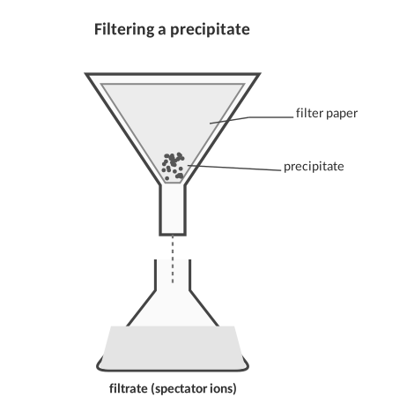
1. Give three reasons the actual yield of a precipitate is usually less than the theoretical yield. Then give one reason a student might get a percent yield greater than 100 %.

2. Methane burns: CH₄ + 2O₂ → CO₂ + 2H₂O.
a. A student reacts 10.0 g of O₂ with excess CH₄. Calculate the theoretical yield of CO₂.
Work:

Answer (units & sig figs): __________________________________
b. The lab produces 6.50 g of CO₂. Calculate the percent yield.
Work:

Answer (units & sig figs): __________________________________
3. CaCl₂ (aq) + 2AgNO₃ (aq) → Ca(NO₃)₂ (aq) + 2AgCl (s)
a. A student reacts 15.0 g of CaCl₂ with 10. g of AgNO₃. Find the limiting reactant and the theoretical yield of AgCl.
Work:

Answer (units & sig figs): __________________________________
b. 4.50 g of AgCl are obtained. Find the percent yield.
Work:

Answer (units & sig figs): __________________________________
4. AlCl₃ + 3NaOH → Al(OH)₃ + 3NaCl
a. 15.0 g of AlCl₃ react with 20.0 g of NaOH. Find the limiting reactant and the theoretical yield of Al(OH)₃.
Work:

Answer (units & sig figs): __________________________________
b. 7.30 g of Al(OH)₃ are collected. Find the percent yield.
Work:

Answer (units & sig figs): __________________________________
5. A reaction has a theoretical yield of 25.0 g. A student collects 21.0 g. The percent yield is…
A) 84.0 % B) 119 % C) 16.0 % D) 46.0 g
PRACTICE
Extra Practice — Unit 6
Show every setup with units.

A. Mole ratios and mass-to-mass
1. Use K₃PO₄ + Al(NO₂)₃ → 3KNO₂ + AlPO₄.
a. How many grams of KNO₂ form from 4.6 mol of K₃PO₄?
Work:

Answer (units & sig figs): __________________________________
b. If 5.8 g of AlPO₄ form, how many grams of Al(NO₂)₃ were used?
Work:

Answer (units & sig figs): __________________________________
c. How many grams of KNO₂ form from 6.2 g of K₃PO₄?
Work:

Answer (units & sig figs): __________________________________
2. Use CO + 2H₂ → CH₃OH.
a. If 5.7 g of CO are used, how many grams of H₂ are also used?
Work:

Answer (units & sig figs): __________________________________
b. If 0.89 g of H₂ are used, how many grams of CH₃OH form?
Work:

Answer (units & sig figs): __________________________________
c. If 15.0 L of CO are used at STP, how many liters of H₂ are also used? Why is no molar mass needed?
Work:

Answer (units & sig figs): __________________________________
B. Limiting reactant and percent yield
3. 10.0 g of Al react with 20.0 g of Cl₂: 2Al + 3Cl₂ → 2AlCl₃. Which is limiting, and how many grams of AlCl₃ can form? How much of the excess reactant is left?
(mol) | 2Al | 3Cl₂ | 2AlCl₃
Before
Change
After

Work and answers:

4. 6.54 g of Zn react with 0.150 mol of HCl: Zn + 2HCl → ZnCl₂ + H₂. Find the liters of H₂ at STP that can form and the grams of the excess reactant left.
(mol) | Zn | 2HCl | ZnCl₂ | H₂
Before
Change
After

Work and answers:

5. A student burns 4.86 g of Mg in air: 2Mg + O₂ → 2MgO. The white powder has a mass of 7.60 g.
a. Calculate the theoretical yield of MgO.
Work:

Answer (units & sig figs): __________________________________
b. Calculate the percent yield and suggest a reason it differs from 100 %.
Work:

Answer (units & sig figs): __________________________________
C. Lab data
6. A student mixes 2.12 g of Na₂CO₃ (in water) with excess CaCl₂ solution: Na₂CO₃ (aq) + CaCl₂ (aq) → CaCO₃ (s) + 2NaCl (aq). The precipitate is filtered, dried and weighed. Data: filter paper 0.86 g; filter paper + dry solid 2.76 g.
(a) Actual yield (b) theoretical yield (c) percent yield

D. Think
7. A recipe makes 24 cookies from 2 cups of flour. You have 5 cups of flour but only 3 eggs, and the recipe needs 1 egg per 8 cookies. How many cookies can you make, and what is the limiting ingredient? Relate this to a chemical reaction.

8. Why must you convert to moles before deciding which reactant is limiting?

9. N₂ + 3H₂ → 2NH₃. If 4 mol N₂ and 9 mol H₂ are mixed, the limiting reactant is…
A) N₂ B) H₂ C) NH₃ D) neither
10. Which quantity cannot be negative or over 100 % in a lab report?
A) percent yield B) actual yield minus theoretical C) mole ratio D) Change in a BCA table
Unit 6 review
11. Write the complete plan (in words) for solving “grams of A → grams of B”. Then say what changes for “liters of gas A → grams of B”.

12. Describe how you find the limiting reactant and how you use it to find the product and the leftover.

